**Magnetometry Activity Answer Key**

**Question 1)** One of the ways archeologists analyze magnetometry maps is by comparing them with other studies, such as contour maps and aerial photos. Compare the magnetometry and contour maps below. What is the significance of the lodge depression in the small red box?

Answer: The contour map barely shows a change in that area. The magnetometry map confirms that the small slope changes are a result of an earthlodge.

**Question 2)** Continue to examine the two maps. Are there more lodge impressions shown in the magnetometry results that do not appear on the contour map? How many lodges total are shown?

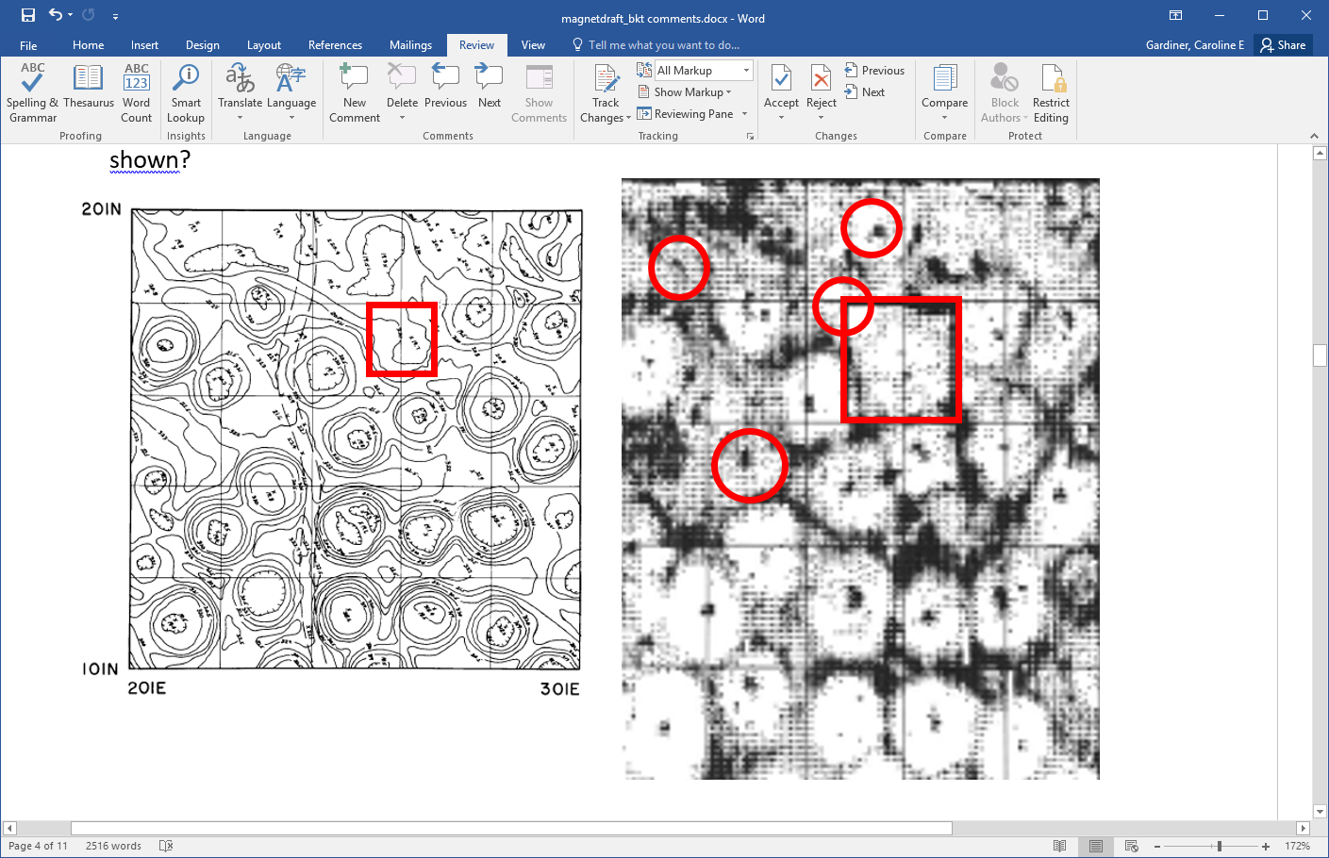

**Answer:** There are at least four additional earth lodges shown within the magnetometry map that do not appear in the contour map. In total, there are about 26 lodges shown. (Note that student interpretations may vary).

**Question 3)** Given that between 10 and 20 people lived within each lodge, how large was the village population? How might archeologists interpret the changing number of earthlodges over time?

**Answer:** At minimum, there were 260 people and at maximum 520 people in the village at one time. Population changes may have occurred due to disease, war, and environmental influences such as drought or river floods.